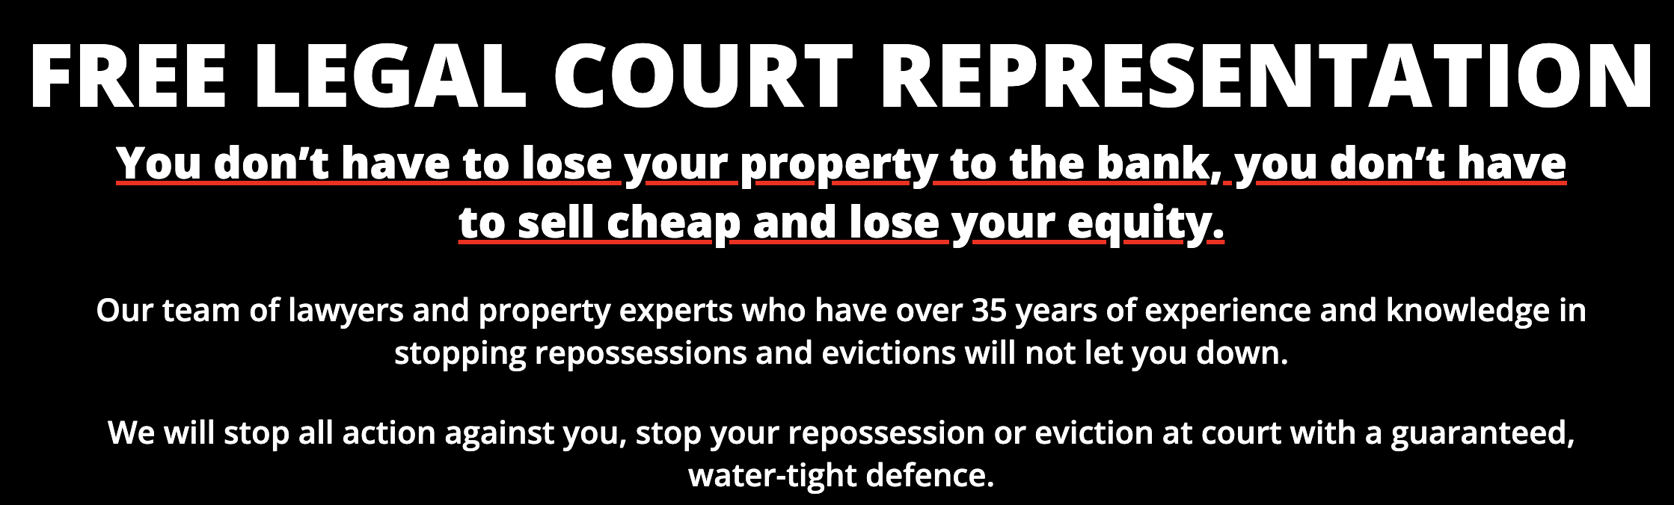

We provide complimentary legal representation in court.

You don’t need to forfeit your property to the bank or settle for a low sale price that results in the loss of your equity. With our team of legal and property professionals, boasting 35 years of expertise, we can halt repossessions and evictions with confidence. Rest assured, we will effectively block any legal action taken against you and present a compelling defence in court.



HOW UKHR CAN ASSIST YOU

NO NEED TO PANIC, NO NEED TO SELL QUICKLY, NO NEED TO SELL FOR LESS Our approach differs from our competitors. We do not intend to purchase your property at a low price.

FACING REPOSSESSION? By engaging our services, we can protect your property, your equity, and your financial security from being compromised.

GUARANTEED 100% REPOSSESSION PREVENTION We offer fast* alternatives, we can purchase your property cash or introduce you to cash buyers.

WE WILL SUPPORT YOU THROUGHOUT Our legal team will submit your N244 application to the court on time and accurately, accompanied by all necessary documents, at no expense to you.

UP TO 6 MONTHS RENT-FREE OPTIONS* We can negotiate a mortgage repayment-free period on your behalf.

LEGAL PROCEEDINGS & COURT SUMMONS The prospect of legal proceedings, such as a court summons for property repossession, can be distressing and have far-reaching implications. Your credit score would be negatively impacted, possibly resulting in homelessness or being blacklisted by credit agencies, limiting your access to loans, mortgages, rental properties, and bank accounts.

YOU COULD LOSE UP TO 40% OF YOUR PROPERTY EQUITY IF REPOSSESSED Our intervention can help prevent this scenario.

AVOID LEGAL & COURT ACTION AGAINST YOU From the moment you engage our services, we will work to halt any legal or court action against you, effectively preventing repossession or eviction. Our emergency legal defence team will prepare a robust defence application on your behalf.

FREE* SOLICITORS TO REPRESENT YOU IN COURT We will pay all of your upfront court expenses. Our specialized legal repossession team can represent you in court within hours, anywhere in the country.

IF YOU DECIDE TO SELL YOUR PROPERTY, WE WILL HELP YOU ACHIEVE THE FULL MARKET VALUE We can provide more favourable options*.

KEEP YOUR PROPERTY Potential property repossession or eviction can be a stressful and overwhelming experience for any homeowner. It can result in financial difficulties, significant upheaval for family members, social stigma, credit blacklisting, and long-term harm.

At UK House Repossessions, our legal team has over 35 years of experience and the expertise required to leave nothing to chance. We obtain results and prevent repossessions and evictions, regardless of your circumstances.

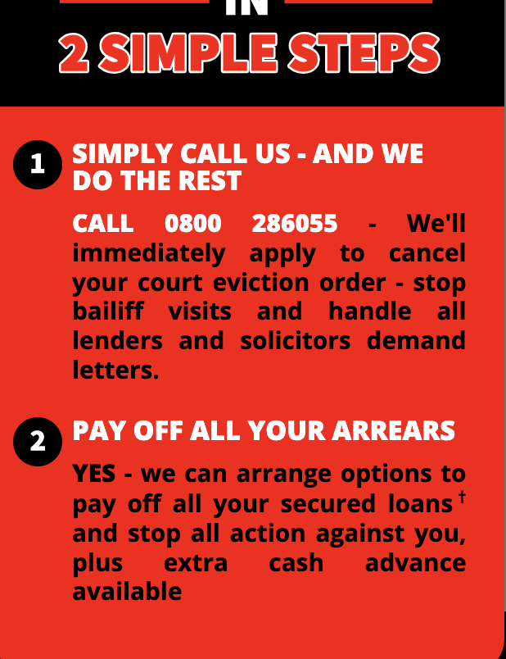

2 Simple Steps

All you have to do is call us at 0800 286055 and we will take care of everything else. We'll apply to cancel your court eviction order, stop bailiff visits, and handle all demands from lenders and solicitors.

Moreover, we can also provide options to pay off all your secured loans† and stop all action against you, along with additional cash advances.

**Accordian Sections:**

What we do

At UKHR, we stand out from our competitors by offering unique and advantageous options to homeowners. Our area of expertise lies in stopping repossessions and evictions for homeowners throughout the UK, and we are fully dedicated to achieving this goal. Our experienced team is committed to providing a professional, effective, and efficient service with no upfront fees required.

We offer solutions that are tailored to benefit homeowners and prevent them from losing their property to the bank. Our strict deadlines ensure that we act quickly when faced with a repossession order or court eviction notice, and our fast-operating rescue model allows us to represent you at court at any stage of the process.

With our team of lawyers, solicitors, property experts, chartered accountants, insolvency experts, and funders, we are well-equipped to achieve the best possible result for you. We take pride in our high success rate in stopping all action against you and finding a solution that suits your needs.

By instructing us, you can immediately relieve yourself from financial pressures and trust that we will work tirelessly to help you keep your property.

Why Choose us

It's not only because we provide an exceptional service without charging upfront fees†, but also because we respond to your enquiry within minutes. Our legal team is always ready to act quickly and halt your eviction or repossession, and we offer various options* to help you regain control of your property. We believe in upholding our core code of practice, which has been our guiding principle since the beginning.

Our clients can rely on us for an exceptional level of customer service throughout the process, and we have a dedicated team of highly experienced professionals committed to helping you. Our team of lawyers specializes in stopping repossessions and evictions and have your best interests at heart.

We have years of experience and knowledge in this field, which we can utilize to help you find the best resolution quickly. Once we have assessed your situation, we will work closely with you to provide the best possible outcome.

†No fees are charged for certain options*. For more information, please contact us.

Repossessions & Evictions

If you are facing repossession or eviction, our legal team can help. We provide a targeted stop repossession service and can stop your repossession at any stage, even making an emergency application to HM Courts on your behalf. Our repossession experts have extensive experience in dealing with both lenders and the Courts, and we can provide you with an expert defence and attend court on your behalf free of charge* to ensure the repossession is stopped.

To prevent repossession, take heed of court letters and act quickly by contacting us for help. We can save your property and enable you to retain your equity, providing you with a stress-free service that addresses your financial problems head-on.

We use the N244 Form to apply for an Emergency Court Hearing, getting your case in front of a Judge so they can decide on whether or not to suspend your eviction notice. Submitting the N244 application correctly is crucial, as an incorrectly completed form cannot delay or stop your eviction. We will complete the N244 Application form for you and establish the grounds for the application.

The Emergency Hearing is your last opportunity to save your home without necessarily having to pay your mortgage arrears in full at that time. Our legal team will support you to secure a positive outcome and prevent a possible eviction. Remember, if you act swiftly, we can help you stop your eviction and save your house.

Free Legal Court Representation

At SHR, we take the matter of legal representation for your eviction case seriously. We understand the importance of having the right team of solicitors and lawyers who possess the necessary experience and expertise to provide you with the best possible representation. We do not take any chances by randomly selecting solicitors, as this could have disastrous consequences for your case. That is why we only work with our trusted and experienced lawyers and barristers based in London, who have a wealth of knowledge in this high-risk area of defence. Our legal experts are some of the most respected and experienced in the UK, and we provide this representation at no upfront cost to you. We do not take risks with solicitors who lack a proven track record of success in this field. We are committed to achieving results for you, and we prepare N244 applications that are approved by the court, resulting in the cancellation of evictions. With SHR, you do not have to lose your equity or property to the bank.

N244 Court Applications

The N244 Application Notice, a form utilized by the County Court for various applications, is necessary for applying for an Emergency Court Hearing to have a Judge determine whether to Suspend your Eviction Notice. The preparation of a strong defense is crucial for obtaining the desired outcome, but timing is also critical. Premature or delayed submission of the form could result in unfavorable consequences.

To halt your eviction, submitting a correctly completed N244 Application is essential. A poorly filled-out form will not prevent or delay your eviction, but with our assistance, the form can facilitate an Emergency Court Hearing that will halt your eviction. Our expertise in completing the N244 Application accurately can save your home by allowing you to have an Emergency Court Hearing.

Submitting an N244 application is not a simple matter as there are various factors that need to be considered before submission. Moreover, it is important that the application is submitted in a timely and accurate manner.

To file the N244, it is not enough to simply have nowhere else to go. You need to have sufficient grounds, and we will help you establish these grounds and complete the form accordingly after assessing your case.

The N244 application should provide enough detail to warrant an Emergency Court Hearing, but it should also be concise. We will assist you in completing the application form to ensure that it is properly assessed by a judge.

It is crucial that you have a strong defense in place, which we will prepare for you prior to any communication with the court.

High Court & County Court

If you have fallen behind on your mortgage payments, your lender may take legal action against you, and you will be summoned to court. During the court hearing, a Master, who is a High Court Judge, will review the cases put forward by you and your lender and decide whether to issue an order for possession, which would allow the lender to repossess the property. The Master will consider all the information provided by both parties before making a decision.

If the Master decides to issue an order for possession, you may still have some options. The Master may give you time to address the arrears or the entire mortgage debt. They can also adjourn the case to allow you to negotiate a repayment plan with your lender, clear the arrears of your loan or mortgage, or prepare further legal arguments.

Postponed Possession Order In situations where the defendant is expected to be able to pay the outstanding mortgage amounts or remedy any other breaches of obligations under the mortgage, the court may delay the date for delivery of possession through a postponed possession order. Such an order will detail how much of the sum the defendant is required to pay should be allocated towards mortgage repayment and how much should be applied to arrears.

A postponed possession order cannot be enforced by the lender without the express permission of the court, which will only be granted after another hearing.

Modifying the Postponed Order If the defendant's circumstances change, such as job loss or salary reduction, the terms of the postponed order may be amended through an application to the court. However, it is crucial to inform the lender of any changes and to reach an agreement with them. Failure to do so may result in the lender seeking a possession order from the court if payments are halted.

If you have been granted a Possession Order but are not yet facing actual repossession, you can seek a Stay of Enforcement from the court to delay the eviction for a specific period of time.

Obtaining a stay can provide you with additional time to arrange a suitable plan to pay off your mortgage or loan arrears, and can also give you the opportunity to find alternative accommodation.

To make a stay application, our legal team can assist you. It is important to do this before the eviction date. You will need to file and serve an affidavit that includes details about who lives in the property, any relevant medical conditions, reasons for the arrears, your current financial situation, and any changes in circumstances since the Possession Order was granted. Additionally, you will need to complete a financial statement.

Presenting a Proposal to the Court To avoid repossession, it is important to present a practical and realistic proposal to the court to pay off either the arrears or the entire mortgage.

Your proposal should demonstrate that you have the ability to repay the arrears within a reasonable period while also maintaining regular mortgage payments. If you offer to pay off the arrears in installments, the proposal must be designed to clear the arrears within a reasonable time frame, preferably before the end of the mortgage term.

The Master will expect you to offer a higher amount if you can afford to do so without jeopardizing your financial stability.

If your circumstances are unclear or further clarification is needed, the Master may adjourn the case. Alternatively, you may arrange to make payments to the lender or sell your property.

It is crucial to act quickly to avoid a repossession order. If you have previously broken the terms of an arrangement agreed upon with the court, it is unlikely that you will receive another favourable ruling. However, there are alternative solutions to stop repossession or eviction, and we specialize in this area. High Court Sheriffs can accelerate the process after obtaining a possession order at the County Court. Contact us as soon as possible to receive the help you need.

Trustees, Bankruptcy & Receivers

Our team consists of a dedicated department of experts and insolvency practitioners who specialize in resolving disputes and negotiating with trustees in bankruptcy, receivers, and LPA receivers. These third-party firms are typically hired by banks, mortgage providers, or bridge finance companies to take control of a property and sell it legally to repay the debt or money owed by the homeowner to the secured lenders.

Our experienced legal team has an in-depth understanding of this intricate field and can assist property owners facing bankruptcy or those who have recently emerged from bankruptcy. We aim to help clients who need specialized expert advice on how to keep their property. Our team is committed to negotiating the best possible deal on your behalf to prevent lenders from instructing receivers in the first place. It's important to act quickly in such situations to prevent matters from escalating.

Rent/ Mortgage Free Period

One of the possible solutions you may consider is a rent-free period and no mortgage payments, but our first step is to halt any repossession proceedings and cancel any impending court eviction notices. Our legal defence team will handle this at no upfront cost to you. After stopping all court action, we can then move on to the next phase, which involves exploring all available options in detail and scheduling a complimentary home visit. It's important to note that whatever option you choose, the repossession or eviction must be stopped first as a priority.

Rent/Mortgage Free Period can usually be arranged when a fast cash buyer has been introduced & exchanges with a releasable deposit to the vendor. This deposit can be used to cover Rent/Mortgage payments. Alternatively, our legal team may liaise with you lender, indicating that a sale is underway & they may agree to halt further mortgage payments up until the sale has completed.

If you receive a repossession order or court eviction notice in the mail, please do not procrastinate. You will have a limited amount of time to file a defence. Contact us without delay for a free, confidential, and non-obligatory conversation.

*Please note this option does not relate to Sale & Rent Back Agreements in any form, this is not an activity which UKHR engages in whatsoever.

Our Team

At SHR, we take great pride in having a team of experts who possess professional, extensive, and profound knowledge. Our team fully comprehends how lenders, banks, mortgage companies, and courts operate when it comes to repossessions and evictions. We also have substantial experience in dealing with trustees in bankruptcy and receivers. Our team is well-versed in working under pressure, time constraints, and strict deadlines, as we understand that prompt, precise action is required to prevent evictions.

We have a group of specialists with diverse expertise, including specialist lawyers, high court barristers, insolvency experts, court advocates, property experts, surveyors/valuers, financial experts, registered chartered accountants, and property investors and funders. We are always available to represent you and are fully equipped to handle all obstacles and complex cases successfully. We can tackle legal final demands, repossession orders, and court eviction notices that you may face, even at very short notice. With us, you can be assured that you are in safe hands.

Simple Process

At SHR, we understand the importance of a simple and straightforward process. As soon as you instruct us, we take control of the situation to eliminate any stress, pressure, or concerns you may have regarding losing your property.

Our first step is to focus on halting any legal or court action against you, which will prevent repossession or eviction from proceeding. Our emergency legal defense team will file a watertight N244 application to ensure that your repossession or eviction is stopped. Once this has been achieved, we will provide you with advice on several options* and implement a solution that best suits your needs. Our goal is to relieve you of any fears and financial pressures, making the process as stress-free as possible.

Maximise Your Equity

At SHR, we understand the overwhelming panic and distress that homeowners experience upon receiving a repossession order or, even worse, a court eviction notice. This is an extremely unpleasant and unsettling time. We understand why many homeowners feel the need to act quickly by contacting fast house buyers and selling their properties quickly and cheaply. However, we operate differently at SHR, and we can assure you that it is not necessary to go down the fast sale route.

We can provide you with much better options* that will benefit you both now and in the future, leaving you in a better financial position. There is absolutely no need to give away your equity when we can help you avoid such a situation.

Don’t Lose Your Property

we understand that it may seem like you have no other option and that your bank or mortgage provider will inevitably take possession of your property, forcing you to consider selling your house cheaply to a cash house buyer. However, we can offer alternative and better options* and solutions.

If you are at the enforcement stage, it is crucial not to ignore any demands or court notices. You need to take immediate action by contacting us so that we can instruct our experienced legal team to prevent your property from being repossessed. Our legal team can still help you even if you have previously been to court with an N244 application regarding eviction related to the same property.

This will provide us with the necessary time to evaluate all of your options* and determine the best package that suits your needs. We will get you back on the road to recovery without losing your property. So, don't hesitate to contact us for swift action and support.

Eviction Notice Form

It is crucial to seek expert help and advice when completing an N244 court application form to have your eviction cancelled. This stage is absolutely necessary and of utmost importance. Incorrect information and reasons provided while completing the N244 could lead to rejection of the application. Additionally, timing is also crucial, as submitting the paperwork too early or too late could have devastating consequences.

At SHR, we can assist you by submitting this application on your behalf, ensuring it is fully completed, accurate, and submitted on time to achieve the desired outcome.

Please note that even if you have been to court on multiple occasions, it is never too late. We can still assist you in stopping your eviction, and all at no upfront cost to you.